Baza de date pentru Netflix

Tema 3

Mincu Adrian-Lucian

grupa 232

Cuprins

Contents

Diagrama conceptuală 2

Exerciții 4

Ex. 5 4

Ex. 7 5

Ex. 9 6

# 

# Diagrama conceptuală

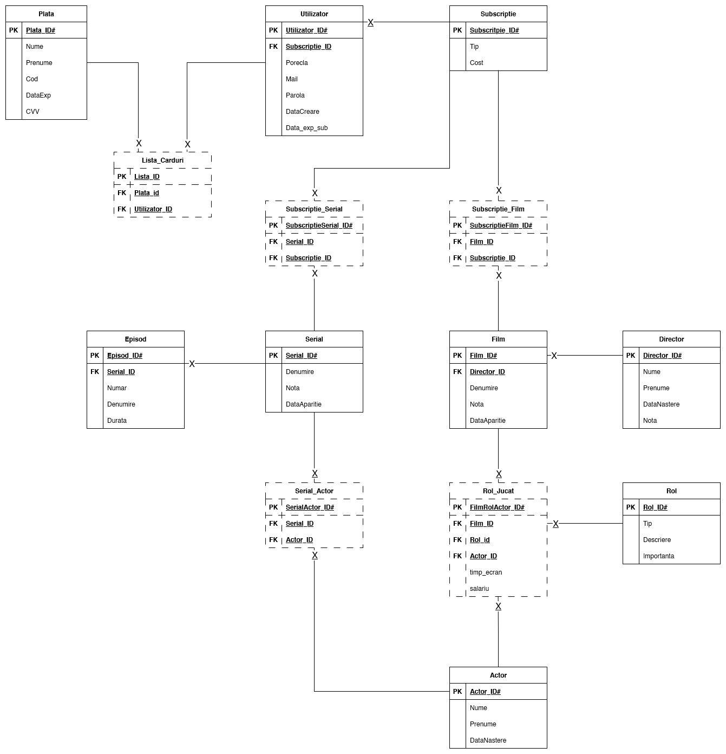

# Exerciții

## Ex. 5

-- tipul subscriptiei cu cele mai multe filme  
DECLARE  
v_subscriptie varchar2(50);  
begin  
 select s.tip  
 into v_subscriptie  
 from SUBSCRIPTIE s, SUBSCRIPTIE_FILM sf  
 where s.SUBSCRIPTIE_ID = sf.SUBSCRIPTIE_ID  
 group by s.tip  
 having *count*(*) = (  
 select *max*(*count*(*))  
 from SUBSCRIPTIE_FILM s2  
 group by s2.SUBSCRIPTIE_ID  
 );  
 DBMS_OUTPUT.*PUT_LINE*('Subscriptia ' || v_subscriptie);  
  
exception  
 when too_many_rows then DBMS_OUTPUT.*PUT_LINE*('There are too many subscriptions with same count of movies');  
end;  
/

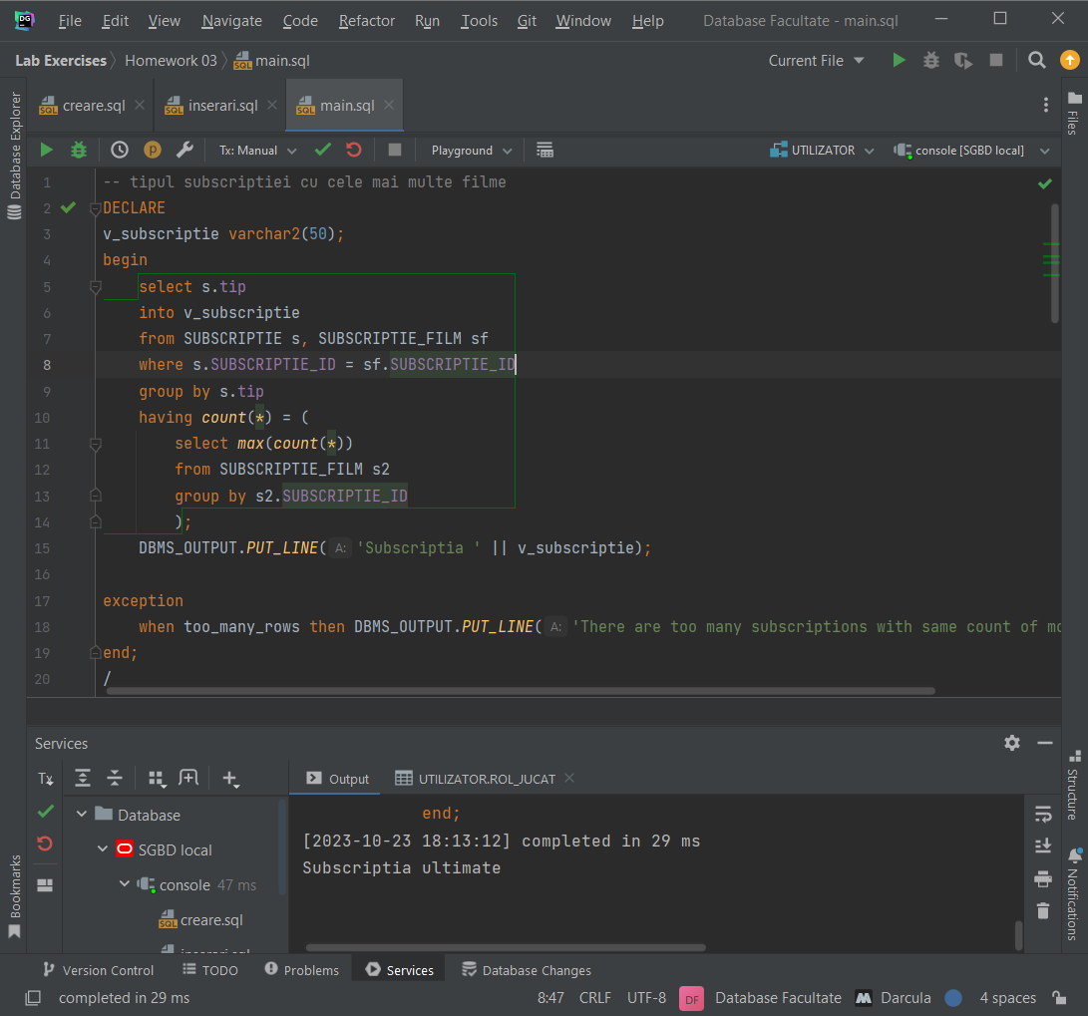

## Ex. 7

-- determinare epoca filmului dat ca id de la tastatura  
declare  
 v_film_id number(6);  
 v_an number(5);  
 v_epoca varchar2(50);  
begin  
 v_film_id := &v_film_id;  
 select *to_char*(DATA_APARITIE,'YYYY')  
 into v_an  
 from FILM  
 where FILM_ID = v_film_id;  
  
 if v_an >= 2000  
 then v_epoca := 'New Era Movie';  
 elsif v_an >= 1980  
 then v_epoca := 'Old Era Movie';  
 else v_epoca := 'Ancient Era Movie';  
 end if;  
  
 DBMS_OUTPUT.*PUT_LINE*('Era of movie with id: ' || v_film_id || ' is ' || v_epoca);  
end;  
/

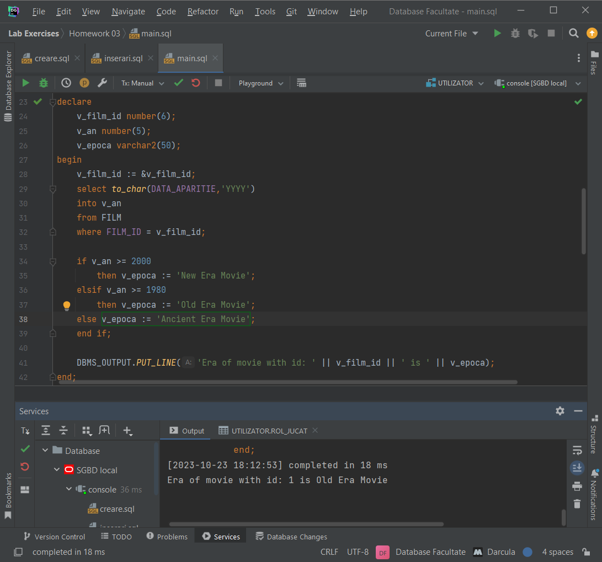

## Ex. 9

-- cod actor, film , si un bonus si sa se mareasca salariul cu noul bonus  
-- sa se mute actorul in filmul nou cu salariul marit cu bonusul dat  
-- daca a mers sa se afiseze "Actualizare realizata" altfel "Nu exista un actor cu acest cod"  
DEFINE v_actor_id = 19  
DEFINE v_film_id = 1  
DEFINE v_bonus = 1000  
declare  
 v_actor_id ACTOR.ACTOR_ID%type := &v_actor_id;  
 v_film_id FILM.FILM_ID%type := &v_film_id;  
 v_bonus NUMBER(6) := &v_bonus;  
 v_rol_jucat_id ROL_JUCAT.FILM_ROL_ACTOR_ID%type;  
begin  
 select FILM_ROL_ACTOR_ID  
 into v_rol_jucat_id  
 from ROL_JUCAT  
 where FILM_ID = v_film_id and ACTOR_ID = v_actor_id;  
  
 update ROL_JUCAT  
 set ACTOR_ID = v_actor_id,  
 SALARIU = SALARIU + v_bonus  
 where FILM_ROL_ACTOR_ID = v_rol_jucat_id;  
 if sql%rowcount = 0 then DBMS_OUTPUT.*PUT_LINE*('Nu exista un actor cu acest id');  
 else DBMS_OUTPUT.*PUT_LINE*('Actualizare realizata');  
 end if;  
  
exception  
 when no_data_found then DBMS_OUTPUT.*PUT_LINE*('Nu au fost gasite date');  
end;  
/

